FUNDAMENTALS OF PROGRAMMING NUST

HANIYYAH ABBAS

481755

SECTION B

#include<iostream>

using namespace std;

#include<vector>

int main() {

Vector<int> Vector;

for (int i = 1; i <= 10; ++i) {

Vector.push_back(i);

}

cout<< “The elements in the vector are : “;

for (auto it = Vector.begin(); it != Vector.end(); ++it) {

cour << *it << “ “;

}

cout <<endl;

Vector.push_back(5);

if (Vector.size() > 5) {

Vector.erase(Vector.begin() + 5);

}

cout << “Vector element after pushing 5 and removing the element at position 5 : “;

for (const auto& element : Vector) {

cout << element << “ “;

}

cout << endl;

return 0;

}

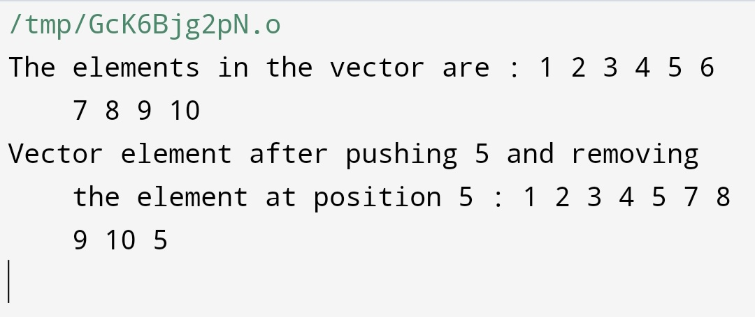

double calculateMean(const vector<int>& studentGrades) {

int sum = 0;

for (int grade : studentGrades) {

sum += grade;

}

return static_cast<double>(sum) / studentGrades.size();

}

double calculateMedian(const vector<int>& studentGrades) {

vector<int> sortedGrades = studentGrades;

sort(sortedGrades.begin(), sortedGrades.end());

size_t size = sortedGrades.size();

if (size % 2 == 0) {

return (sortedGrades[size / 2 - 1] + sortedGrades[size / 2]) / 2.0;

} else {

return sortedGrades[size / 2];

}

}

vector<int> calculateMode(const vector<int>& studentGrades) {

map<int, int> gradeCount;

for (int grade : studentGrades) {

gradeCount[grade]++;

}

int maxFrequency = 0;

for (const auto& pair : gradeCount) {

maxFrequency = max(maxFrequency, pair.second);

}

vector<int> modeGrades;

for (const auto& pair : gradeCount) {

if (pair.second == maxFrequency) {

modeGrades.push_back(pair.first);

}

}

return modeGrades;

}

int main() {

vector<string> studentNames;

vector<int> studentGrades;

int numEntries;

cout << "Enter the number of students: ";

cin >> numEntries;

for (int i = 0; i < numEntries; ++i) {

string name;

int grade;

cout << "Enter name for student " << i + 1 << ": ";

cin >> name;

cout << "Enter grade for student " << i + 1 << ": ";

cin >> grade;

studentNames.push_back(name);

studentGrades.push_back(grade);

}

double mean = calculateMean(studentGrades);

cout << "Mean of the grades: " << mean << endl;

double median = calculateMedian(studentGrades);

cout << "Median of the grades: " << median << endl;

vector<int> modeGrades = calculateMode(studentGrades);

cout << "Mode of the grades: ";

for (int mode : modeGrades) {

cout << mode << " ";

}

cout << endl;

cout << "Names of students with the mode as their grade: ";

for (size_t i = 0; i < studentGrades.size(); ++i) {

if (find(modeGrades.begin(), modeGrades.end(), studentGrades[i]) != modeGrades.end()) {

cout << studentNames[i] << " ";

}

}

cout << endl;

return 0;

}

